ASSIGNMENT - 03

1. Write a shell script to print message : “This is my first shell script”

and also the system date and time in the following format :

“Today’s date is DD:MM:YY” “

Now the time is HH:MM:SS

Code:

echo "This is my first shell script"

current_date="Today's date is `date +%d:%m:%Y`";

current_time="Now the time is `date +%H:%M:%S`";

echo $current_date;

echo $current_time;

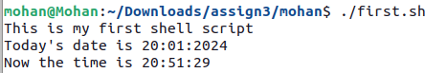

1. Write a shell script which takes two strings as inputs, concatenates them and displays the resulting string.

Code:

read -p "enter the first string : " str1

read -p "enter the second string : " str2

str1+=$str2;

echo "$str1"

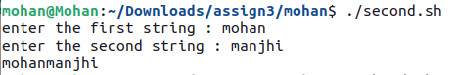

3. Write a shell script which reads three inputs a,b,c and calculates d,e,f as following, and displays their values:

i. d = a+b+c

ii. e = (a-b)*c

iii. f = (a*b)/c

CODE:

read -p "Enter the value of a : " a

read -p "Enter the value of b : " b

read -p "Enter the value of c : " c

d=$((a+b+c))

e=$(((a-b)*c))

f=$(((a*b)/c))

echo "a + b + c : $d"

echo "(a - b) * c : $e"

echo "(a * b) / c : $f"

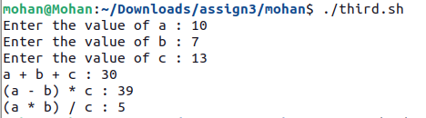

1. Write a shell script to calculate average of set of N numbers; numbers given as input.

CODE:

echo "Enter number"

read n

i=1

sum=0

echo "Enter num "

for((i=1; i<=n; i++))

do

read num

sum=$((sum+num))

done

sum=$((sum/n))

echo "The avg of given number is : $sum"

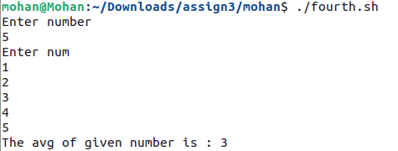

5. Write shell script which takes three numbers as input and finds largest among them.

CODE:

echo "enter the numbers "

read a

read b

read c

if [ $a -gt $b ] && [ $a -gt $c ]

then

echo $a

elif [ $b -gt $a ] && [ $b -gt $c ]

then

echo $b

elif [ $c -gt $a ] && [ $c -gt $b ]

then

echo $c

fi

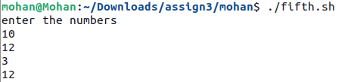

6. Write a shell script which accepts a string from terminal, echoes a suitable message if it doesn’t have at least 10 characters.

CODE:

echo "Enter a String"

read String

len=`echo -n $String | wc -c`

if [ $len -lt 10 ]

then

echo "String is less then 10"

fi

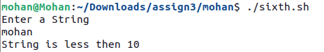

7. Write a shell script to find out the factorial of given number.

CODE:

read num

sum=1

for((i=1;i<=num;i++))

do

sum=$((sum*i))

done

echo $sum



8. Write a shell script to accept the percentage marks of the students and then to display the division.

Use case statement for the same.

CODE:

echo "Test Score"

read score

case $score in

100) echo "A" ;;

9[0-9]) echo "A" ;;

8[0-9]) echo "B" ;;

7[0-9]) echo "C" ;;

6[0-9]) echo "D" ;;

*) echo "F" ;;

esac

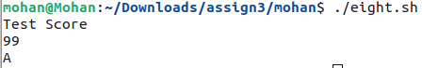

9. Write a shell script to copy the contents of an array to another array and also display the same.

CODE:

echo "old"

orignal=("Anushtha","Harshita","Mohan")

copy=${orignal[*]}

echo $orignal

echo "copy"

echo $copy ${copy[1]}

